**SUPERVISED MACHINE LEARNING: REGRESSION**

**MODULE 3:**

**CROSS VALIDATION**

**TABLE OF CONTENTS**

**Cross-Validation Concepts 2**

K-Fold Cross-Validation 2

Types of K-Fold Cross-Validation 2

Standard K-Fold 2

Stratified K-Fold 3

Group K-Fold 3

Model Complexity and Choice of K 4

**Regularized Linear Models 4**

Ridge Regression (L2 Regularization) 5

Lasso Regression (L1 Regularization) 5

Elastic Net (Combination of L1 and L2) 6

Selecting the Best Alpha with Cross-Validation 6

Bias–Variance Trade-Off 8

**Key Takeaways 8**

# 

# 

# Cross-Validation Concepts

* Cross-validation is a method to **assess how well a model generalizes** to unseen data.
* Instead of one train-test split, the dataset is divided into multiple parts (*folds*).
* The model is trained on some folds and validated on the remaining ones, and this process is repeated to obtain an **average performance metric** that reduces random bias.

## K-Fold Cross-Validation

* In **K-Fold Cross-Validation**, the dataset is split into *k* folds:
  + Train the model on *k – 1* folds and validate it on the remaining fold.
  + Repeat *k* times so each fold serves once as validation.
  + The final score is the **average across all folds**.

## Types of K-Fold Cross-Validation

### **Standard K-Fold**

* Randomly splits data into *k* folds of equal size.
* Works well for balanced, independent datasets.

| from sklearn.model_selection import KFold, cross_val_score  from sklearn.linear_model import Ridge  # Define model  ridge = Ridge(alpha=1.0)  # Standard 10-fold CV  kf = KFold(n_splits=10, shuffle=True, random_state=1)  scores = cross_val_score(ridge, X, y, cv=kf, scoring='neg_mean_squared_error')  print("MSE for each fold:", -scores)  print("Average MSE:", -np.mean(scores)) |
| --- |

### Stratified K-Fold

* Maintains the same class distribution in each fold.
* Suitable for **imbalanced classification problems**.

| from sklearn.model_selection import StratifiedKFold, cross_val_score  from sklearn.linear_model import LogisticRegression  from sklearn.datasets import load_breast_cancer  # Load data  data = load_breast_cancer()  X, y = data.data, data.target  # Define model  model = LogisticRegression(max_iter=5000)  # Stratified 5-fold CV  skf = StratifiedKFold(n_splits=5, shuffle=True, random_state=42)  scores = cross_val_score(model, X, y, cv=skf, scoring='accuracy')  print("Accuracy per fold:", scores)  print("Average accuracy:", scores.mean()) |
| --- |

# 

### Group K-Fold

* Keeps **related samples** (e.g., from the same group or person) in the same fold.
* Prevents **data leakage** between training and validation.

| from sklearn.model_selection import GroupKFold  from sklearn.linear_model import LinearRegression  from sklearn.metrics import mean_squared_error  import numpy as np  # Create dummy groups  groups=np.array([i//10 for i in range(100)])# 10 samples per group  # Define model and Group K-Fold  model = LinearRegression()  gkf = GroupKFold(n_splits=5)  for fold, (train_idx, val_idx) in enumerate(gkf.split(X, y, groups)):  model.fit(X[train_idx], y[train_idx]) # Train on groups  preds = model.predict(X[val_idx]) # Validate on unseen groups  print(f"Fold {fold+1} MSE:", mean_squared_error(y[val_idx], preds)) |
| --- |

## Model Complexity and Choice of K

| **Model Type** | **Description** | **Common Issue** |
| --- | --- | --- |
| **Low Complexity** | Simple, few parameters | Underfitting |
| **High Complexity** | Many features, very flexible | Overfitting |

* **Smaller k (e.g., 2–3):** higher variance, less stable results.
* **Larger k (e.g., 10–20):** lower variance, more stable but computationally expensive.

# Regularized Linear Models

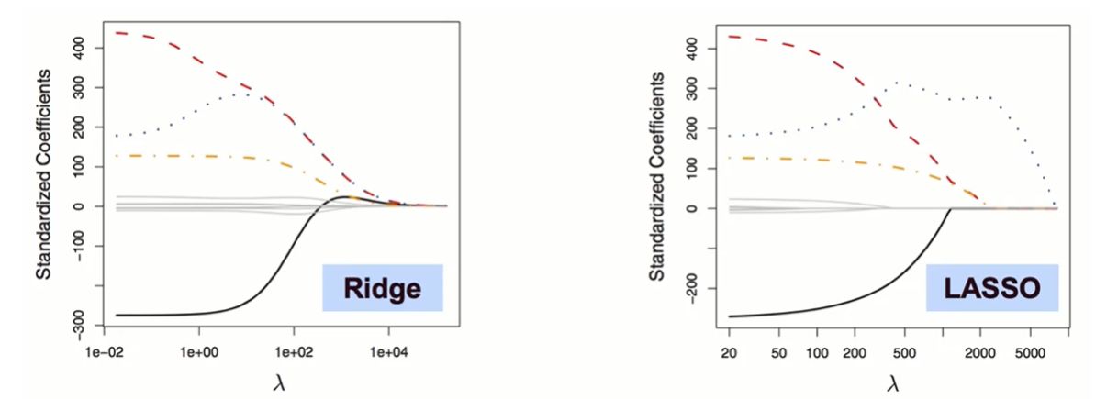

Regularization reduces overfitting by adding a **penalty term** to the cost function, keeping coefficients small and improving generalization.

| ***Minimize (Loss+Penalty)*** |
| --- |

## Ridge Regression (L2 Regularization)

**Adds a squared penalty:**

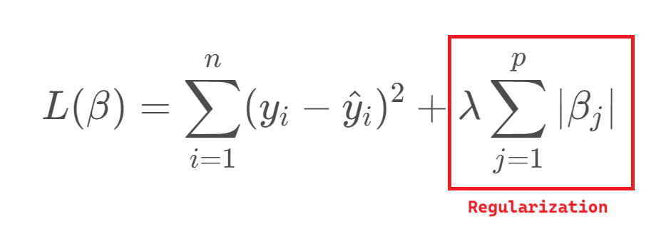

* Shrinks all coefficients but keeps them nonzero.
* Useful when all predictors contribute slightly.

| from sklearn.linear_model import Ridge  from sklearn.metrics import mean_squared_error  ridge = Ridge(alpha=1.0)  ridge.fit(X, y) # Train model  print("Ridge Coefficients:", ridge.coef_) |
| --- |

## Lasso Regression (L1 Regularization)

**Adds an absolute penalty:**

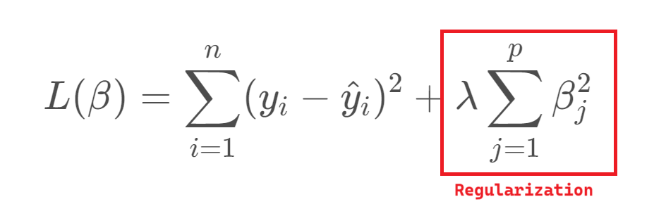

* Some coefficients become exactly zero → **automatic feature selection**.
* Best when only a few features are important.

| from sklearn.linear_model import Lasso  lasso = Lasso(alpha=0.05)  lasso.fit(X, y)  print("Lasso Coefficients:", lasso.coef_) |
| --- |

## 

## Elastic Net (Combination of L1 and L2)

**Combines Ridge and Lasso penalties:**

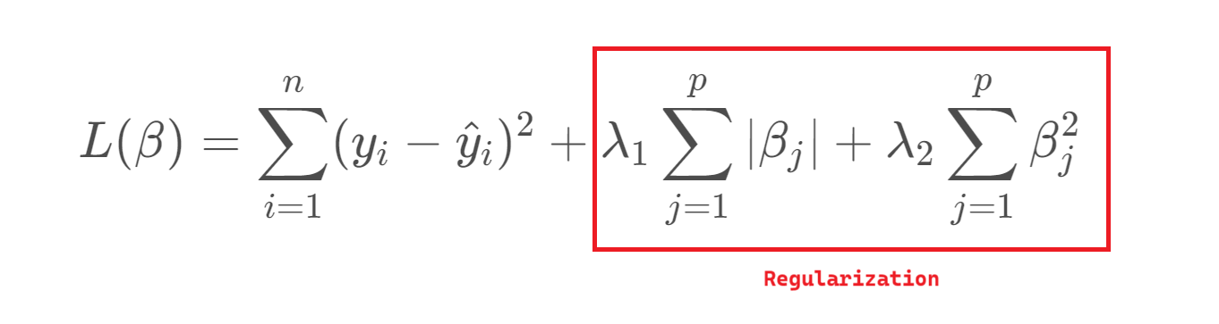

* Balances Lasso’s sparsity and Ridge’s stability.
* Works well for correlated features.

| from sklearn.linear_model import ElasticNet  elastic = ElasticNet(alpha=0.5, l1_ratio=0.5)  elastic.fit(X, y)  print("Elastic Net Coefficients:", elastic.coef_) |
| --- |

## 

## Selecting the Best Alpha with Cross-Validation

* Scikit-learn provides built-in models that automatically choose the best alpha (regularization strength) using K-Fold Cross-Validation.
  + **RidgeCV**

| from sklearn.linear_model import RidgeCV  # Define candidate alpha values  alphas = [0.01, 0.1, 1.0, 10.0]  # Automatically select best alpha via 5-fold CV  ridge_cv = RidgeCV(alphas=alphas, cv=5)  ridge_cv.fit(X, y)  print("Best alpha (RidgeCV):", ridge_cv.alpha_)  print("R² Score:", ridge_cv.score(X, y)) |
| --- |

* + **LassoCV**

| from sklearn.linear_model import LassoCV  # Automatically tunes alpha using cross-validation  lasso_cv = LassoCV(alphas=[0.001, 0.01, 0.1, 1.0], cv=5, random_state=42)  lasso_cv.fit(X, y)  print("Best alpha (LassoCV):", lasso_cv.alpha_)  print("Selected Coefficients:", lasso_cv.coef_)  print("R² Score:", lasso_cv.score(X, y)) |
| --- |

* + **ElsticNetCV**

| from sklearn.linear_model import ElasticNetCV  # Elastic Net tunes both alpha and l1_ratio  elastic_cv = ElasticNetCV(  alphas=[0.001, 0.01, 0.1, 1.0],  l1_ratio=[0.2, 0.5, 0.8],  cv=5,  random_state=42  )  elastic_cv.fit(X, y)  print("Best alpha (ElasticNetCV):", elastic_cv.alpha_)  print("Best l1_ratio:", elastic_cv.l1_ratio_)  print("R² Score:", elastic_cv.score(X, y)) |
| --- |

## Bias–Variance Trade-Off

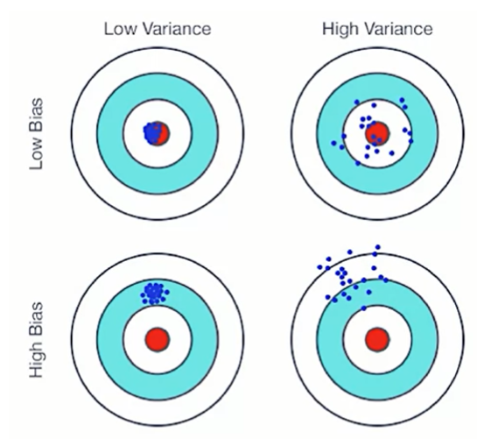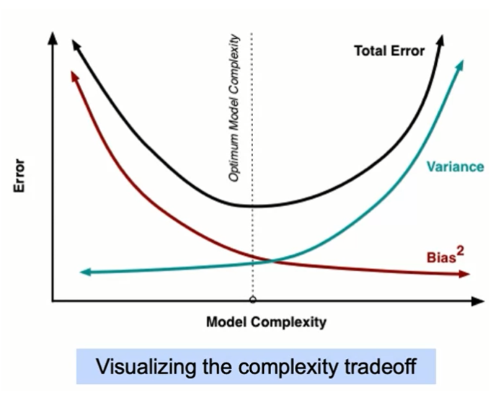

* Increasing regularization (larger alpha):
  + Increases **bias**
  + Decreases **variance**
* Too little regularization → overfitting
* Too much regularization → underfitting
* The best model strikes a balance between the two.

# Key Takeaways

* **Cross-Validation** Evaluates model stability by rotating train-test splits for fair performance estimation.
* **K-Fold Variants**
  + *Standard:* Random splits.
  + *Stratified:* Keeps class proportions.
  + *Group:* Prevents leakage across related samples.
* **Model Complexity** K-Fold helps detect underfitting (too simple) or overfitting (too complex).
* **Regularization** Adds penalties to limit model flexibility and reduce overfitting.
* **Ridge (L2):** Shrinks all coefficients smoothly.
* **Lasso (L1):** Performs feature selection.
* **Elastic Net:** Balances sparsity and stability.
* **Cross-Validation + Regularization:** Use CV (RidgeCV, LassoCV, ElasticNetCV) to pick the best alpha for optimal bias–variance balance.
* **Core Insight:** Combining **Cross-Validation** and **Regularization** produces models that are **accurate, interpretable, and generalizable**.